IT24103496

WELIANGA L.D.L

# Exercise

## 1)

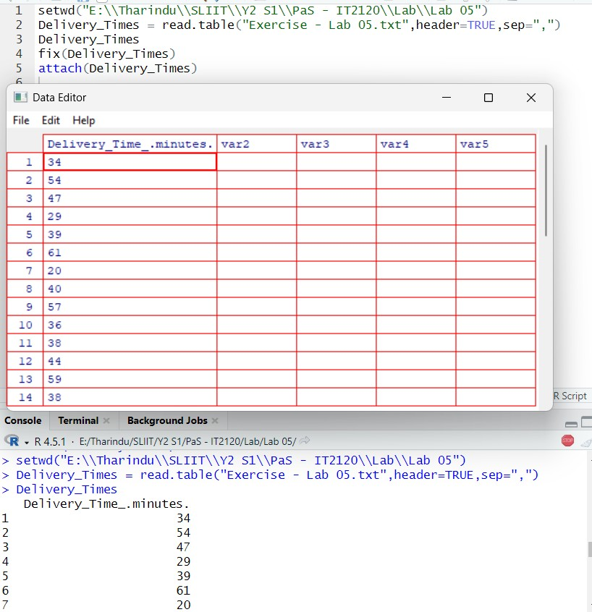

## 2)

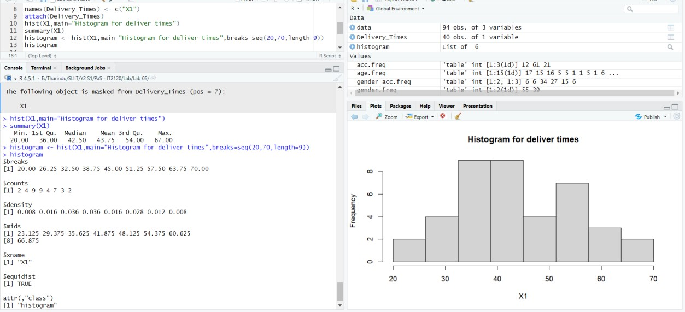

3) Bi-Model Shaped

## 4)



